SUBMITTED TO : INSHA ALTAF

SUBMITTED BY :

GURKIRAT SINGH 2210990339

GUNTAS SINGH 2210990334

HARMANJEET SINGH 2210990372



CLASS RESULT

MANAGEMENT

SYSTEM



AIM OF THE

PROJECT

❑

STUDENT RECORD

MANAGEMENT SYSTEM STORES

AND TRACKS STUDENT’S

GRADES

AND PERCENTAGE

PERFORMANCE

❑

IT ENSURE BETTER

INTERACTIONS BETWEEN

TEACHERS,STUDENTS AND

PARENTS

20

XX

Pitch Deck

2



***WHY PYTHON?***

Operating Data in MS

-

Excel

❑

It takes a lots of efforts to

compute data in MS

-

excel as

we have to do many things

manually.

❑

With lots of efforts, it also takes

a lot of time.

❑

We cannot export this data on

internet with ease

Operating Data in Python Programming

❑

It

takes

less

efforts

to

compute

data

in

python

programming

as

many

things

are

predefined

and

happen

automatically

.

❑

Code

generally

runs

in

milliseconds

.

❑

We

can

also

export

data

on

internet

using

pandas

library

of

Python

Programming

language

.

# GET ACCESS

There is an access to use the record .limited access is given to people for security purpose.

# PANDA LIBRARY

The popular python library called pandas which is used for working with data sets. It has functions for analysing ,cleaning ,exploring and manipulating the data

# 3.MATPLOTLIB

Matplotlib is a cross-platform ,data visualization and

graphical plotting library for python and its numerical extension Numpy.

FEATURES OF THE

PROJECT

**AUTHENTICATION :**

To protect the data from inauthenticated users

we ask for user to enter the so that limited and

authenticated user can access the data e.g

teachers have the authentication to access

student record

20

XX

Pitch Deck





**ACCESSING THE DATA**

20

XX

Pitch Deck

Press 1: To check the percentage of each student.

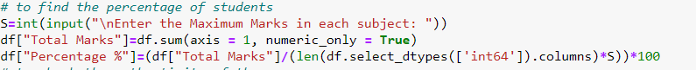

Press2 : To check the grade of each student.

**IMPORTING DATA FROM EXCEL :**

We have used read excel function of panda to import

data from MS

-

Excel to python data frame





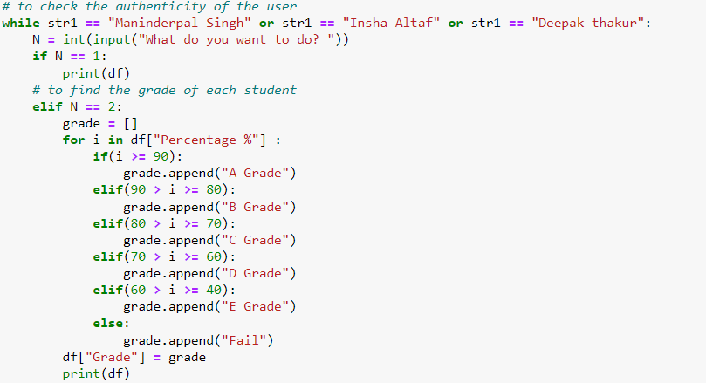

Press3 : To check any particular student Record

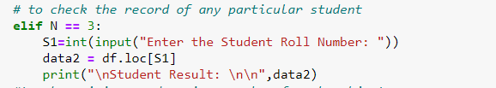

Press6 : To see the composition of marks in class in pie form

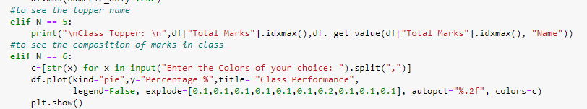

Press5 : To see the topper name



Press4 : To check the minimum and maximize marks of each subject

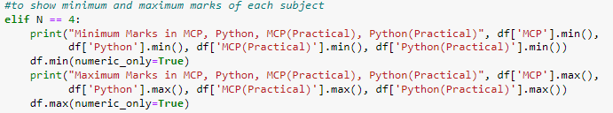

FUTURE SCOPE

Its really helpful for stundents , teachers and parents and in future

With a lot of data its easy to maintain and handle data for teachers .

We can add more functions and we can also add attendance system in this code .

ROLE ASSIGNMENT

Gurkirat Singh Guntas Singh Harmanjeet Singh

2210990339 2210990334 2210990372

Logic thinking Test case run complilation

And presenting And importing And importing

The code excel sheet Matplotlib

20XX Pitch Deck



THANKS FOR WATCHING